8th Annual Mountain State Speech and Hearing Conference
Sponsored by WVU NSSLHA & SAA

Friday, April 6th, 2018
8:30am – 3:30pm
Registration 7:45 - 8:30am
Gluck Theater, WVU Mountainlair

Parking: WVU Mountainlair Parking Garage, $1.50/hour (card and cash)

Using Case Studies to Understand the Treatment Paradigm for Stuttering
Tommie L. Robinson, Jr., PhD, CCC-SLP
Children’s National Health System
Disclosure: No relevant financial or nonfinancial relationships to disclose.

Overview of Diagnosis and Management of Auditory Processing Deficits
Vishakha W. Rawool, PhD, CCC-A
West Virginia University
Disclosure: Author for Thieme Medical Publishers and receives royalty payments.

This course is offered for .55 ASHA CEUs

There will be a lunch break from 11:30 – 12:30pm.
Lunch options will include: Taziki’s, Saikou Sushi, Hatfields, Sbarro, Chick-fil-A, Burger King, or Which Wich.
*Lunch will be at your expense.

Contact Information:

Name: ______________________________________________ Phone: __________________

Address: __________________________ City: __________________ State: ________ Zip: _______

Email: _________________________________________________

Do you want to receive CEU Credit? Yes ____ No ____

Do you need accommodations? Hearing ____ Vision ____ Seating ____

Please check the option that applies to you:
Registration – Mailed by March 30, 2018
Price will increase by $5.00 at the door.

[ ] Student - $ _____ ($10) Major: ________________________ Graduate/Undergraduate (circle one)

[ ] Clinical Supervisor for WVU - $ _____ ($20) Site: _______________________

[ ] Professional - $ _____ ($40) Occupation: ________________________

Payment information: Mail payments to: Lauren Johnson
Check _____ Cash ______ WVU NSSLHA Treasurer
P.O. Box 6122
805 Allen Hall
Make check payable to WVU NSSLHA Morgantown, WV 26506

Would you like a receipt? Yes ____ No ____

*Payments are non-refundable
*Registration will be available at the door.
*Presentation materials will be posted online in PDF format for you to download or print.

Cut along line and save bottom portion for your reference.
Room Reservations:
A block of rooms have been reserved for those interested in staying overnight on April 5th or April 6th at:

Holiday Inn
1188 Pineview Drive
Morgantown, WV 26505
Phone: (304) 241-6649

Last day to book under discounted rate: March 26th. Mention the Mountain State Conference upon booking.
Group code: MSC
RSVP as soon as possible, as there is a limited amount of rooms.

Directions from the hotel to the conference location:

Head south on Pineview Drive toward WV-705 E
Turn left at the stoplight onto WV-705 E
Straight through three stoplights to the roundabout
Take a slight right toward the Mileground Road (at the roundabout)
Continue onto Willey Street
Merge onto University Avenue
Your destination will be on the right
Take immediate right to enter parking garage.

The Gluck Theater is located on the main level of the Mountainlair behind JACS Convenience Store.
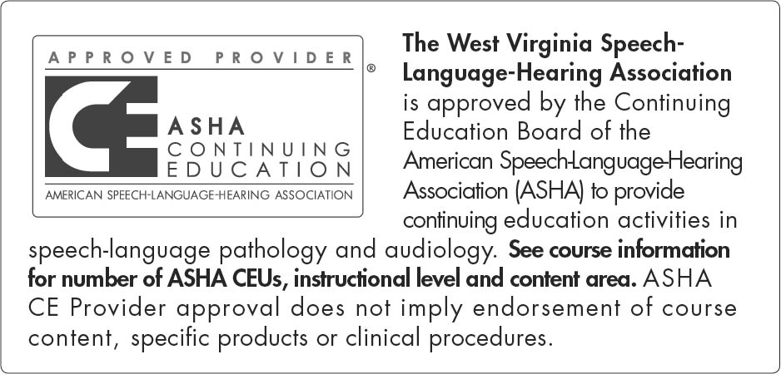

This course is offered for up to .55 ASHA CEUs (Various level, Professional Area)

